Peugeot 306 GTI-6/Rallye: Buying Guide

One of the true hot hatch greats, now's the time to bag a GTI-6 before it's too late - here's how

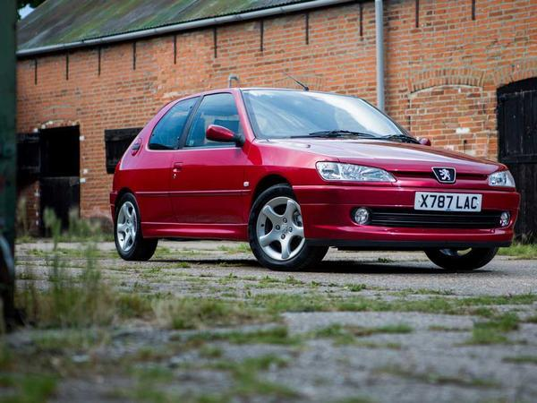

When the Big Book of Hot Hatchery comes to be written, it may well record that Peugeot's finest example was not the sainted 205 GTI. Yes, it was the one that put the French firm on the performance map. But perhaps the best fast hatch it's made is the 306 GTI-6, and its lightweight Rallye derivative.

[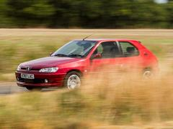](http://images.pistonheads.com/nimg/34887/Peugeot306GTI6BuyingGuide_006-L.jpg)

Introduced in 1996, power for the GTI-6 came from a naturally-aspirated 2.0-litre petrol motor producing 170hp at 6,500rpm. With 142lb ft at 5,500rpm, it dealt with 0-62mph in 7.8 seconds and headed on to 135mph. These figures seem moderate by today's standards, but the GTI-6 was about much more than just off-the-line speed.

What makes the car so special is the way it gets down the road. A kerb weight of 1,215kg for the GTI-6 makes it very light next to most current hot hatches and the Rallye version stripped a further 52kg from the bottom line thanks to ditching front fog lights, air-con, electric windows and the sunroof. The Rallye also had unique upholstery that was less weighty than the GTI-6's cloth and Alcantara mix, which was standard from early 1998.

Both versions shared the same six-speed manual gearbox, with long first and second gears that also means initial acceleration wasn't as vivid as you might think. However, on the move, the engine was praised in road tests for its eagerness to rev.

[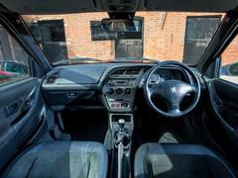](http://images.pistonheads.com/nimg/34887/Peugeot306GTI6BuyingGuide_011-L.jpg)

The handling and steering also came in for considerable plaudits as they allowed the Peugeot to shine on any sort of road. Supple on bumpy back roads, it turned in with plenty of feel at the wheel and offered ample grip. Like its predecessors from the same firm, the rear end would step out if provoked but it was also faithful for keen drivers who kept their right foot on the throttle.

A 1997 facelift saw new headlights, grille, bumpers, doors, instrument panel and side protection arrive, while another update was applied in mid-1999. These last Phase 3 cars have 'crystal' headlights, clear side repeater indicators, round foglights, silver dash trim and an aluminium gear knob.

In total, around 4,500 GTI-6 of all types and 500 Rallyes were sold in the UK. Many of those have now disappeared from our roads, making this superlative hot hatch one to look out for and cherish when you find a good, original example. Prices are unpredictable at the moment, with running cars with MoT from £1,000. Immaculate, low mileage models like the one supplied for our photos by Pemberton Cars are being advertised for up to £8,000, which might seem optimistic until you consider the way prices for 205 GTIs are going. As such the 306 GTI-6 and Rallye's time may yet be to come, so now is the time to bag a good 'un and here's how.

306 GTI-6 Buying Guide: Powertrain

Zingy and characterful but check that service record

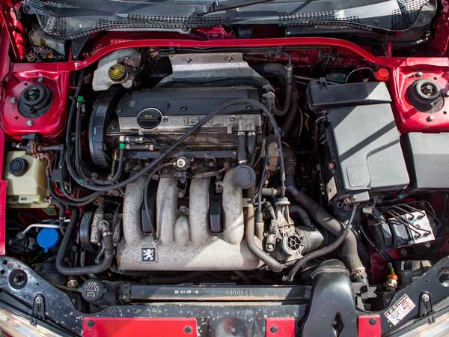

The 2.0-litre XU10J4RS engine used in the 306 GTI-6 and Rallye is unchanged between the two models and the three phases of the car's life. It's a robust unit, but with one major caveat: the timing belt.

Peugeot originally specified a 70,000-mile interval before dropping this to 40,000 miles or five years. Even then, plenty of belts snapped before the car reached the 40,000-mile mark and left owners with an expensive fix. It's now reckoned a new belt every 30,000 or three years is the safe limit. With any GTI-6 or Rallye you're thinking of buying, check the service records very closely for receipts to prove when the timing belt was last changed, and look for evidence the water pump was swapped at the same time. Even with cars where this work has been carried out, you should still reckon on replacing the belt and pump as routine service items to be on the safe side for around £300 at a specialist.

[](http://images.pistonheads.com/nimg/34888/Peugeot306GTI6BuyingGuide_006-L.jpg)

Any car with a ticking noise that rises as the engine is revved has probably had a snapped timing belt and poor repairs. Some noise from the fuel injectors when the engine is cold is common, but this will stop when the engine warms through.

If the XU10J4RS engine doesn't idle smoothly from cold, a new idle control valve and stepper motor should solve it. Make sure you use a correct and original spec Magnetti Marelli unit so it lasts a long time - aftermarket items are known to fail quickly.

As well as the water pump, the cooling system in the GTI-6 should be inspected carefully. Keep an ear out for the thermostatic cooling fans switching on when the engine begins to get hot. The cooling system is fragile and radiators corrode. Replacement radiators are easy to fit and many owners upgrade to an aftermarket aluminium item for improved efficiency.

With your head still under the bonnet, check the area where the top engine mount fixes to the bodyshell as it can crack and let the engine start to move unnecessarily.

Air-con pipes corrode and are also prone to damage from underneath as they sit low to the ground. Few cars will have functioning air con as a result as many owners don't bother to spend the £300 to replace pipes that will almost inevitably be damaged again.

A heavy clutch was common when new and it gets heavier with age as the routing of the hydraulic pipes passes close to the exhaust and the cable's grease dries out on right-hand drive cars. Replacing the cable will cost £35 plus fitting or you could do it yourself in around three hours for the competent home mechanic.

With the engine in good health, you can expect around 30mpg in typical daily driving, which will drop to as low as 18mpg when driving the car hard on the road or track.

# For more power, aftermarket exhausts add to the sound but little to the overall horsepower. Freeflow induction kits should be fitted with caution as some mount the inlet very low in the engine bay, which risks scooping up water from deeper puddles and potentially causing the engine to hydraulic. Some cars have had supercharger kits fitted, which can provide up to 300hp.

# 306 GTI-6 Buying Guide: Rolling chassis

Simple but effective and key to the GTI-6's character

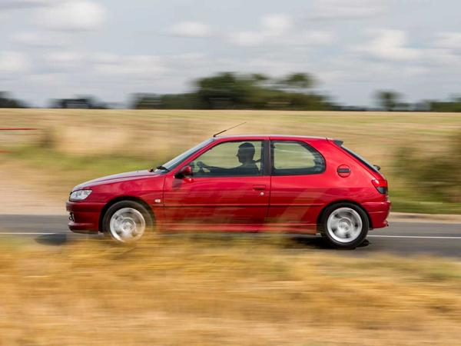

The GTI-6 and Rallye have a simple MacPherson strut, coil spring and shock absorber with anti-roll bar front set-up. At the back, a torsion beam with trailing arms, coil springs and anti-roll provides the suspension.

[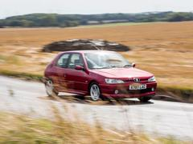](http://images.pistonheads.com/nimg/34889/Peugeot306GTI6BuyingGuide_005-L.jpg)

The torsion beam rear end has an undeserved reputation for being snappy and tail-happy. Worn bushes will make it less predictable, while poly bushes are not the best bet for road use as they remove some of the passive rear steer from set-up. The bushes between the boot floor and torsion bar also fail and cause a banging noise, but it's simple enough to sort this, albeit quite time consuming.

Cars that have been lowered need not be shunned, so long as good quality front springs are used, such as Eibach ones. Also, the rear beam needs to be carefully lowered to match the front to avoid a tail-up stance. Doing this will almost undoubtedly show up seized bushes, so budget for replacing these with original or uprated ones depending on the type of use you have in mind.

A GTI-6's steering will feel quite heavy to anyone used to modern assisted systems, but the pay-off is superb feedback. Listen out for worn drop links, which are simple to replace. The originals were made from plastic, but metal replacements are available. The turning circle is not great as Peugeot had to limit the lock to allow for clearance for the six-speed gearbox, while 3.2 turns between the stops doesn't feel especially quick for a hot hatch. However, the steering is one of the defining traits of this car.

[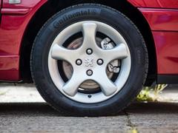](http://images.pistonheads.com/nimg/34889/Peugeot306GTI6BuyingGuide_014-L.jpg)

Peugeot fitted 6Jx15-inch Cyclone alloy wheels, which are cheap to refurbish and their 195/55 VR15 tyre size means there's lots of choice for those on a budget and anyone looking for stickier track day rubber. Balancing the wheels can be tricky as they don't have a centre cap, so make sure any fitter knows how to balance this type of wheel.

The 283mm ventilated front discs and 240mm solid rears are well up to the job of stopping the GTI-6 as it has an all-up weight of 1,215kg, or 1,163kg for the Rallye. Check the rear calipers are working and let the wheels rotate freely, even if the car has a recent MoT pass to its name.

306 GTI-6 Buying Guide: Body

Know your facelift - a GTI-6 spotter's guide

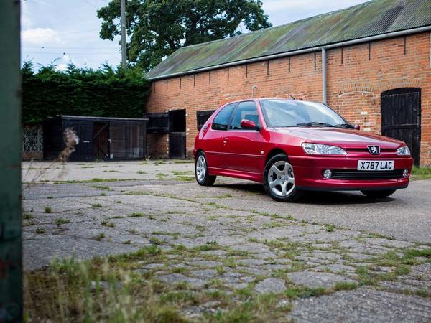

Peugeot built the GTI-6 in three phases, which can be determined from the outside. The Phase 2 revamp arrived in mid-1997 with new headlights, grille, bumpers, doors, instrument panel and side protection, while another update was applied in mid-1999. These last Phase 3 cars have 'crystal' headlights, clear side repeater indicators, round foglights, silver dash trim and an aluminium gear knob. All three phases of 306 GTI-6 have their own rear parcel shelf design.

[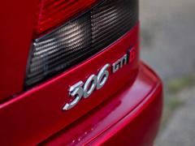](http://images.pistonheads.com/nimg/34890/Peugeot306GTI6BuyingGuide_010-L.jpg)

The steel monocoque shell is galvanised but rot can appear behind the sills and in the nearside front wheelarch. For some reason, Peugeot didn't always fit an arch liner to the front nearside arch so stone chips will develop into corrosion. Also have a look around the rear seat belt mounts and the surrounding area for rust as this is an MoT fail point.

Check the fuel filler elbow joint if you can as it rots and is tricky to access to replace, so have a good sniff for any whiff of petrol in the cabin and boot that might indicate this.

Otherwise, there's little to worry about the with the GTI-6 and Rallye beyond the usual inspection for crash damage and poor repairs. You may find most cars have a fair smattering of parking dings and dents. While this is age-related, the thin metal used on the doors and wings means they are more prone than contemporary rivals, such as the Volkswagen Golf GTI.

306 GTI-6 Buying Guide: Interior

Check those electrics...

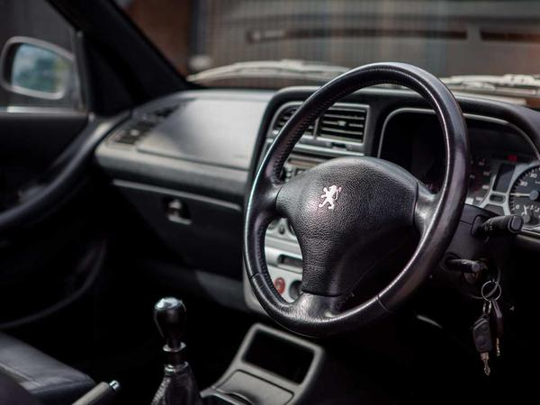

Most 306 GTI-6s have leather and Alcantara upholstery, which looked great when new and the seats offer excellent support. However, age often sees the driver's side outer bolster wear and split, which looks awful but can be fixed by a professional upholsterer. The rest of the interior trim is no better or worse at lasting the distance than most cars of this age and generation.

[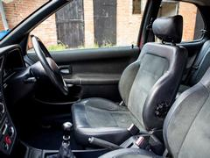](http://images.pistonheads.com/nimg/34891/Peugeot306GTI6BuyingGuide_017-L.jpg)

While sat in the driver's seat, look up for signs of water leaking into the cabin through blocked drain holes if there's a sunroof fitted.

When you turn on the ignition, make sure the oil temperature gauge is also working to tell you the oil level. Check the electric windows and door mirrors work as the door looms are known to break. Try this with the doors open and closed. Another electrical fault that shows up is the airbag warning light not going out after the car is started. This is most likely a broken wire under the seats and is simple to remedy.

Central locking fails as water gets in though the aerial hole and causes the electrical PCB to stop working.

306 GTI-6 Buying Guide: At a glance

The essential checklist if you're viewing a GTI-6

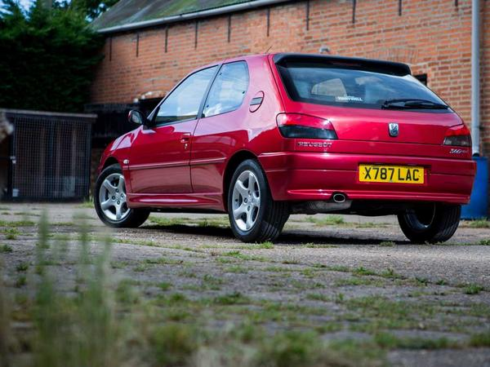

Powertrain  
Timing belt is a weak spot and can fail at less than 40,000 miles; make sure it's been changed recently or budget for this and a new water pump  
A ticking noise from the engine when it's warm indicates a previous cambelt failure  
Listen for the thermostatic fans cutting in if the engine gets hot  
A new radiator is a wise move as soon as you buy a GTI-6  
Air con pipes corrode and are easily damaged as they sit low under the radiator  
Clutch cables become stiff with age; a replacement is £35 and transforms the drive

[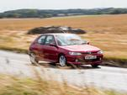](http://images.pistonheads.com/nimg/34892/Peugeot306GTI6BuyingGuide_005-L.jpg)

Rolling chassis  
Suspension bushes wear and spoil the handling  
Poly bushes are best reserved for track cars as they lessen the passive rear steering of the GTI-6  
Listen out for rattling worn drop links  
Cyclone alloy wheels don't have centre caps, so need careful balancing

Body  
Thin steel is easily dented in car park dings  
Some cars didn't have a nearside wheelarch liner, which can lead to corrosion  
Fuel filler elbow joint wears and leaks fuel; sniff for any signs of this  
Check for rust around the rear seat belt mounts

[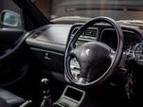](http://images.pistonheads.com/nimg/34892/Peugeot306GTI6BuyingGuide_013-L.jpg)

Interior  
Worn front seat bolsters are very common but easy to have repaired  
Sunroof drain holes get blocked and allow water to leak into the roof lining  
Almost every electrical component should be suspected of failure  
Make sure electric windows and mirrors work with the doors open and closed